Madbury Church
Ham & Bean Supper

Delicious Baked Ham

Homemade Beans
Salad Bar & Breads
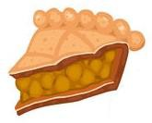

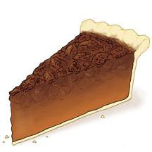


Handcrafted Fruit & Cream Pies

Saturday, October 18, 2025
5:00 to 6:30 PM
Madbury Town Hall
Adults: $12 Kids under 12: $6

